**TEST CASE**

* **Create a New Test Case**
  + **Name: My Test 3**

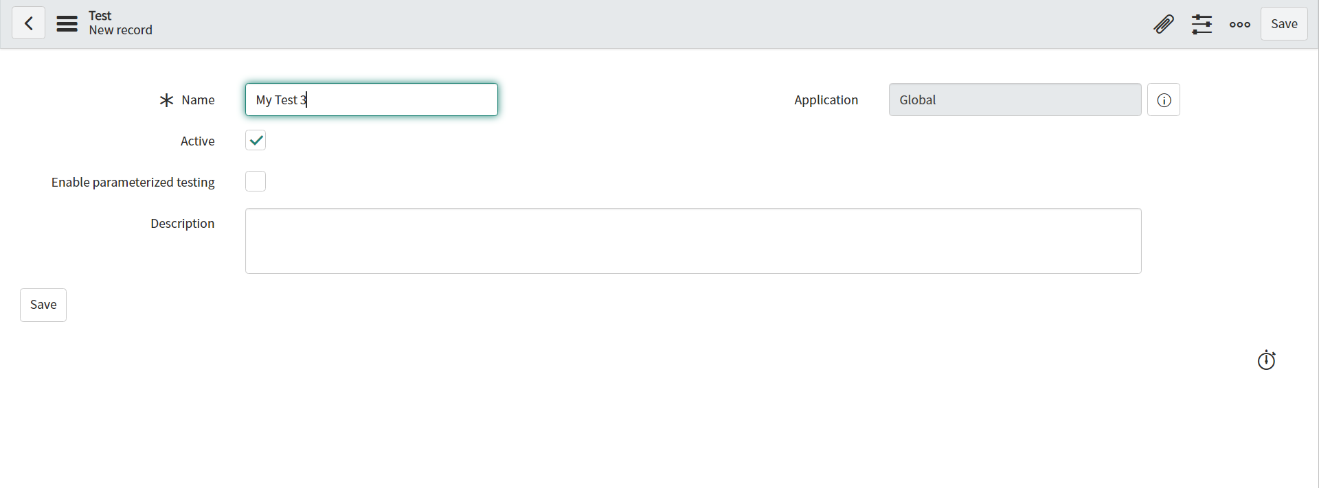

* **Add Test Step**
  + **Open a New Forn**

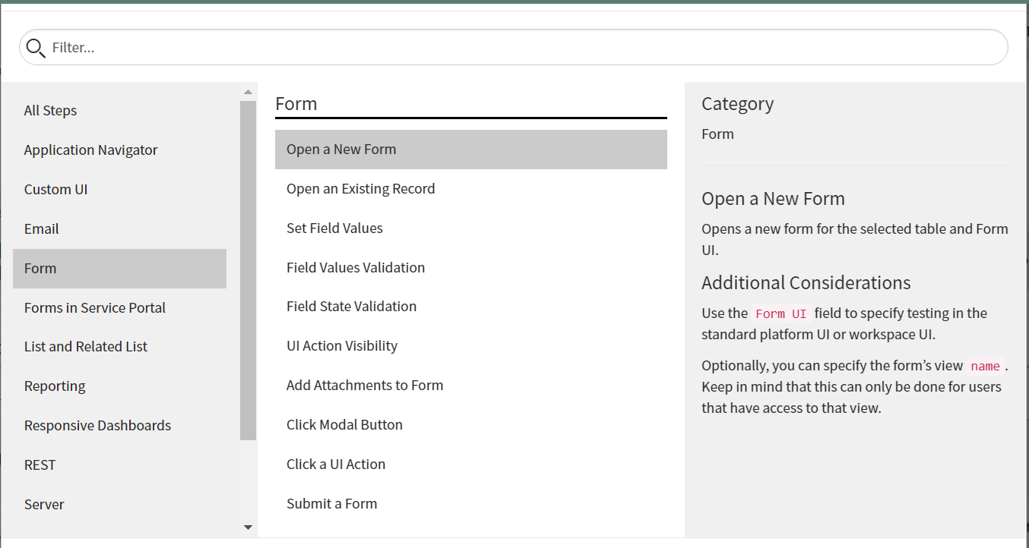

* **Choose Table – Incident Table**

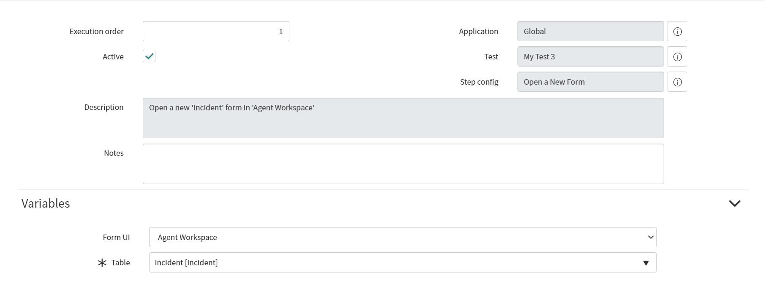

* **Add Test Case**
  + **Set Field Values**

**Enter Short Description – Hi**

**Caller – Abel Tuter**

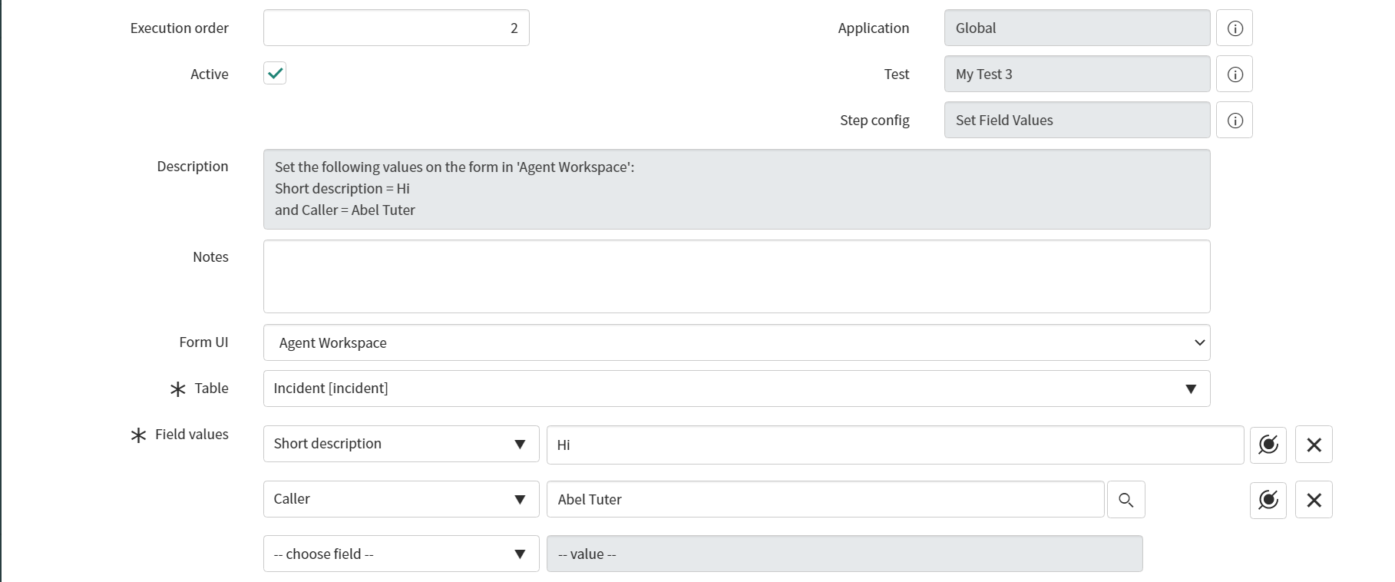

* **Test in Standard View**

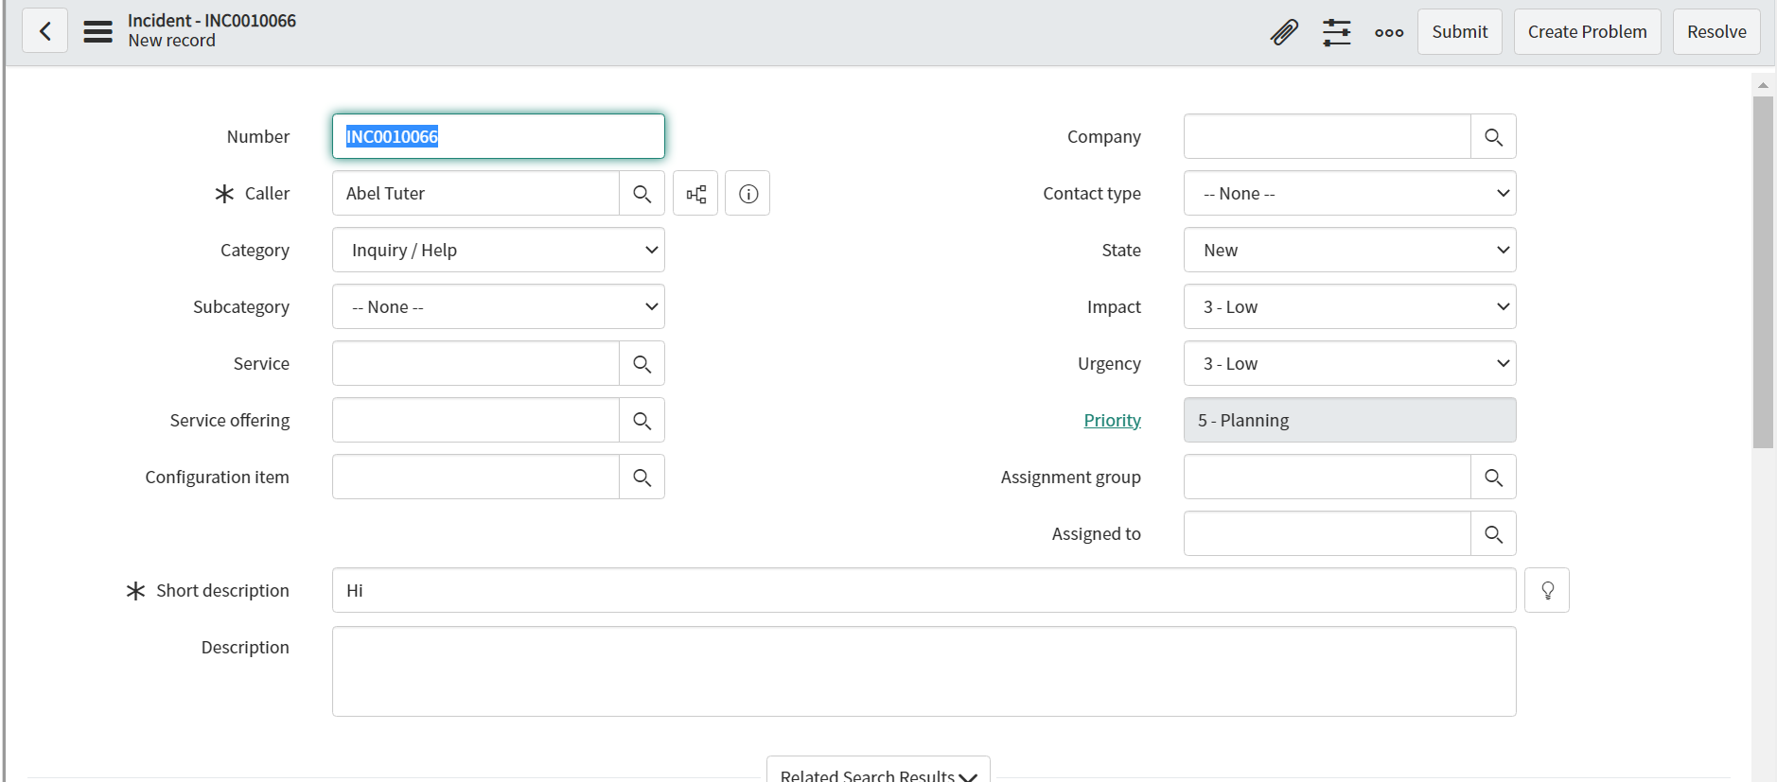

* **Test in Agent Workspace**

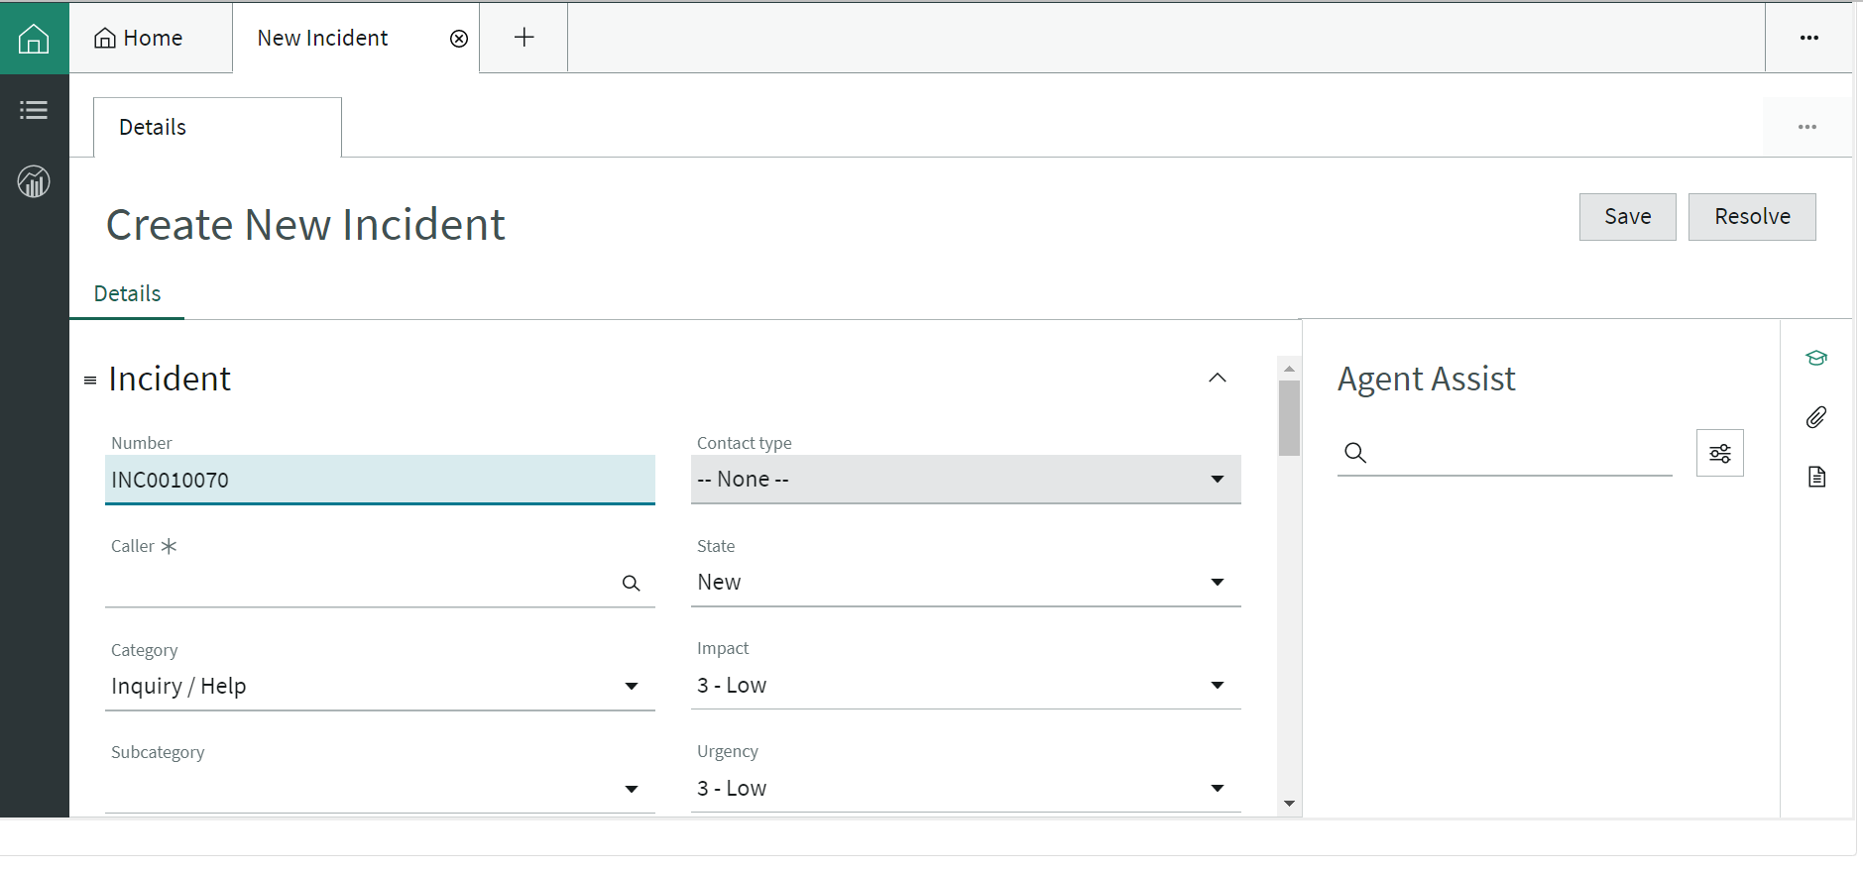

**TEST CASE – SERVICE CATALOG**

1. **OPEN A CATALOG ITEM**

**Add Test Step**

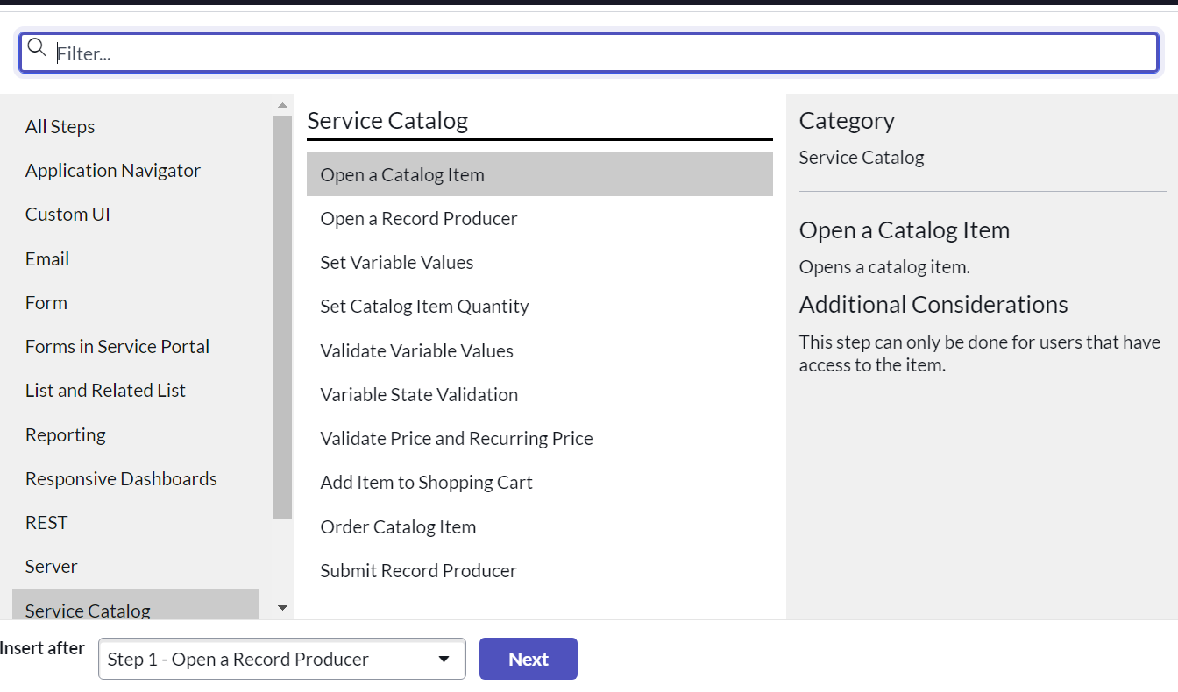

**Now we open any of the Catalog Item – Adobe Acrobat Pro**

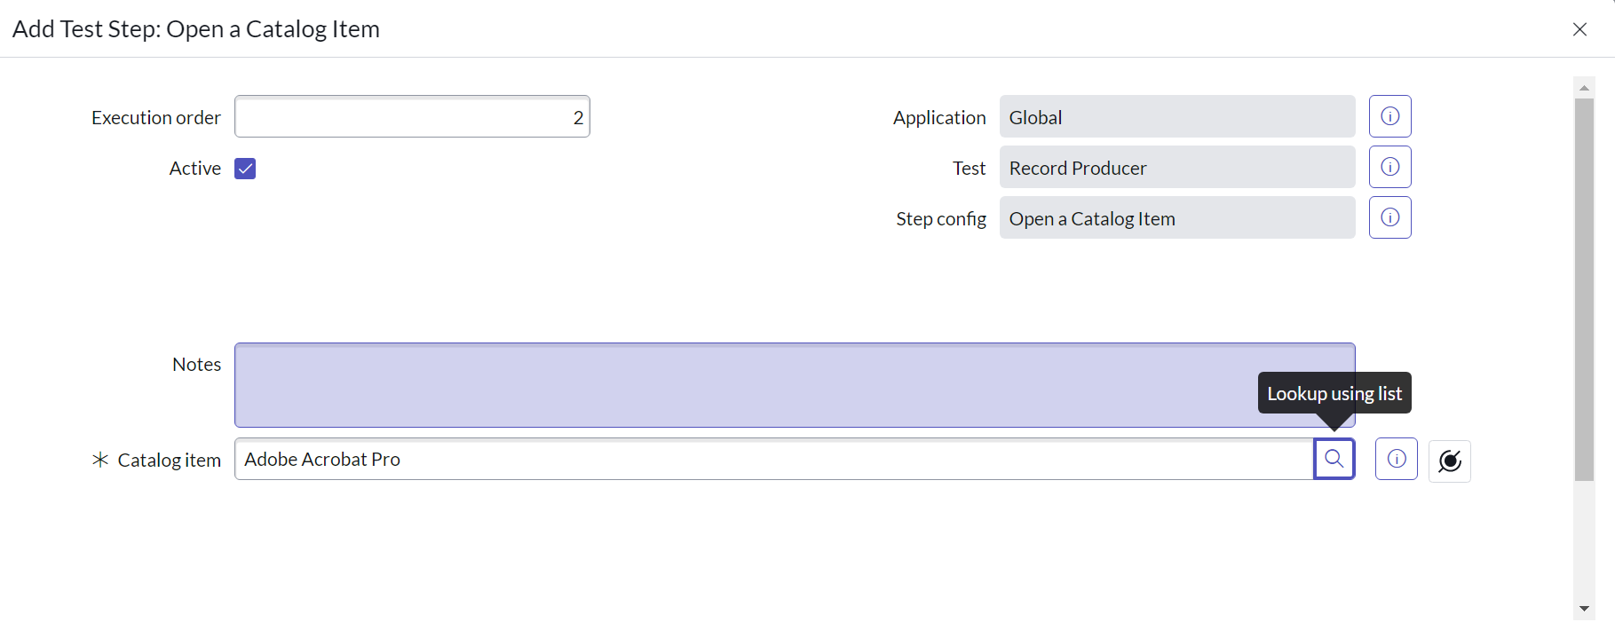

**Run Test**

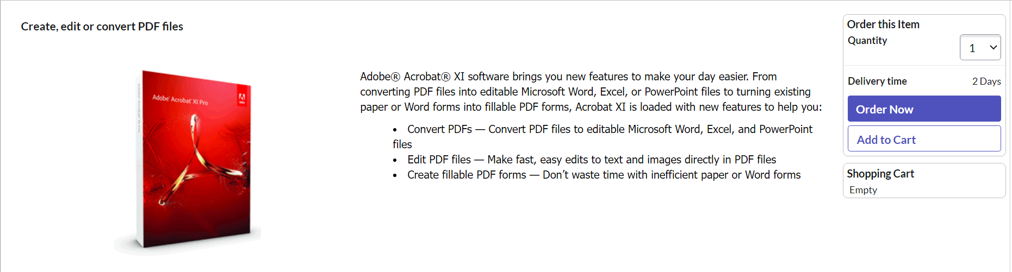

1. **Open Record Producer**

**Add a Test Step**

**Open a Record Producer – Reboot Windows Server**

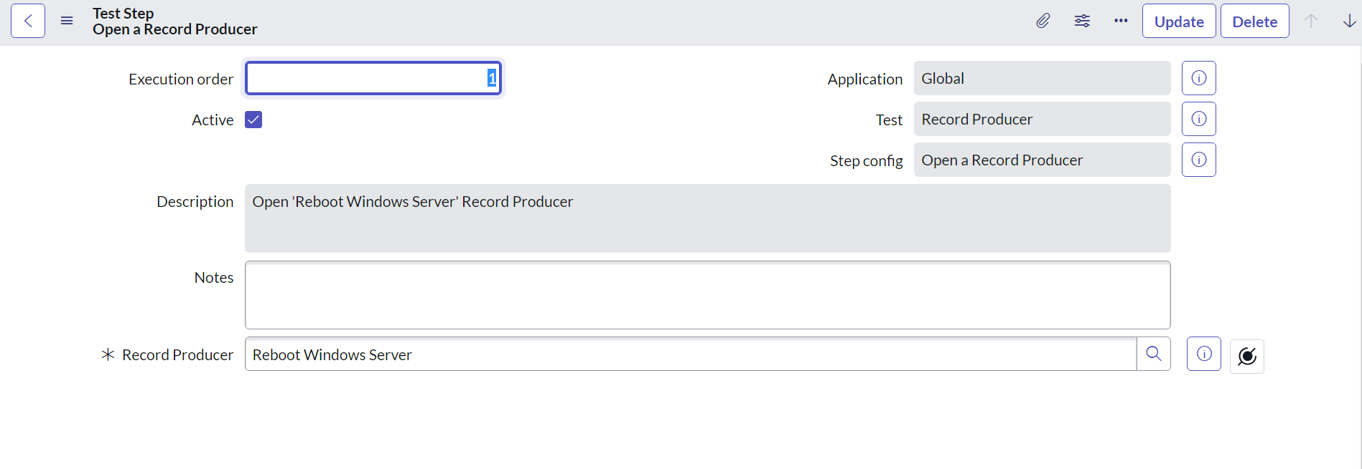

**Run Test**

